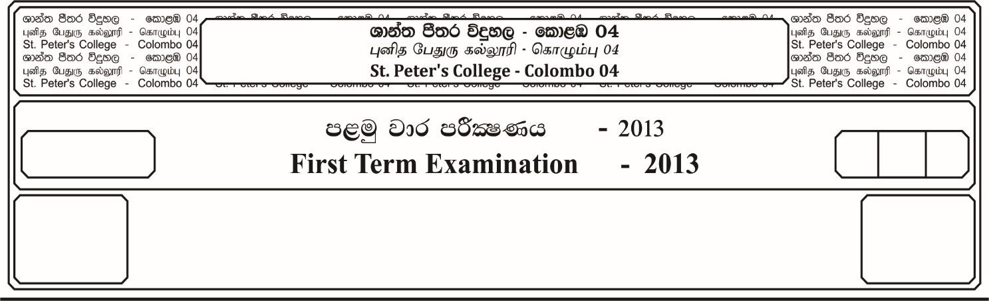

13 fY%aKsh

GRADE 13

E

$03$ meh

$03$ Hour

II

**m<uq jk jdr mÍCIKh - 2023**

**First Term Examination - 2023**

wd¾Ól úoHdj- ¸¸

**ECONOMICS – II**

**Instructions; There are five questions in this paper and all questions are compulsory.**

01. i. Distinguish between following,

a). Common property resources and renewable resources.

b). Globle public goods and national public goods.

ii. Describe, using production possibilities curves, how economies can grow faster if they are willing to cut back on current consumption.

iii. Contrast how a market economy and a command economy try to cope with the problem of scarcity.

iv. “Market forces recognize only private costs and benefits of production and consumption.” Are there others costs and benefits in production and consumption? If so, why are such costs and benefits not recognised by the market operators? Explain the economic consequences of such market behaviour?

v. What conditions must be satisfied if resources are to be used efficiently in an economy?

***(04 Marks per each)***

02. i. Explain what is meant by price effect in demand. ***(04 Marks)***

ii. Explain the difference between the factors that determine the supply of a firm and the market. ***(04 Marks)***

iii. You are given the following demand and supply functions of a competitive market.

Qd = 100 – 4P

Qs = -30 + 6P

Define excess demand and excess supply and derive the excess demand and excess supply equations. ***(04 Marks)***

iv. The following are the market demand and market supply equations of a commodity in a perfectly competitive market.

Qd = 600 – 10P

Qs = 10P

Assume that the government implements a price supports system where it agrees to buy the surplus output with the guaranted price of Rs. 50 for this product.

Calculate the following;

a). Consumer outlay and producer revenue under the price support policy.

b). Change in consumer surplus and producer surplus.

c). The cost incurred by the government.

d). The deadweight loss. ***(08 Marks)***

03. i. Distinguish between production and supply.

ii. Both short – run and long – run average total cost curves are U shaped. Why?

iii. A firm faces the following cost and revenue schedules;

|  |  |  |
| --- | --- | --- |
| **Output (Q)** | **Total Revenue (TR)** | **Total Cost (TC)** |
| 0 | 0 | 3 |
| 1 | 6 | 5 |
| 2 | 12 | 8 |
| 3 | 18 | 12 |
| 4 | 24 | 17 |
| 5 | 30 | 23 |
| 6 | 36 | 30 |
| 7 | 42 | 38 |
| 8 | 48 | 47 |

Calculate the profit, marginal revenue, marginal cost and state what the profit maximizing output will be for the firm.

iv. What is meant by natural monopoly?

v. Draw the demand, marginal revenue and marginal cost curves for a monopolist. Show the profit – maximizing level of output and price. ***(04 Marks per each)***

04. i. What is meant by economic agents? Explain using a diagram, the relationship among economic agents. ***(04 Marks)***

ii. What is meant by production boundary? What are the economic activities belonging to the production boundary? ***(04 Marks)***

iii. You have been given the following data for a hypothetical economy.

|  |  |
| --- | --- |
| **Item** | **Rs. Million** |
| Private consumption | 6400 |
| Public consumption | 3600 |
| Gross domestic capital formation | 4000 |
| Changes in stocks | 500 |
| Export of goods and services | 3500 |
| Import of goods and services | 4500 |
| Net primary income from rest of the world | -400 |

Calculate gross national income. ***(04 Marks)***

iv. The following model represents a closed economy with government.

C = 500 + 0.8 Yd

I = 600

G = 400

T = 150 (values are in Rs. billion)

a). How much is the autonomous expenditure in this economy?

b). What is the equilibrium level of aggregate output?

c). What is the value of savings at the equilibrium?

d). What is the value of tax multiplier? ***(08 Marks)***

05. i. What is meant by money? ***(02 Marks)***

ii. Why people demand money? ***(03 Marks)***

iii. Distinguish between near money and money substitutes? ***(02 Marks)***

iv. What are the characteristics of a good money? ***(03 Marks)***

v. What are the functions of a commercial bank? ***(02 Marks)***

vi. Assume that in a banking system has cash reserves of Rs. 200 billion, loans of Rs. 800 billion and deposits of Rs. 1000 billion.

a). If the statutory reserve ratio is 8%, what is the maximum amount of new loans that the banking system could make in future?

b). What will be the new level of banks assets and liabilities. ***(04 Marks)***

vii. Assume that in a hypothetical economy during a given period of time total money supply was Rs. 7200 billion, total amount of bank deposits held by the public was Rs. 6000 billion, statutory reserve ratio was 10% and the value of excess reserves held by the banks was Rs. 200 billion. What was the value of money multiplier? ***(04 Marks)***